### Current Activities

It’s been another relatively quiet couple of months, with curators taking vacation.

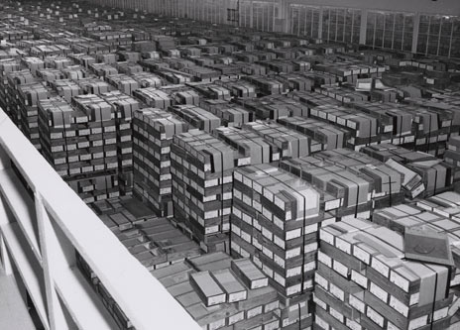A new page has been added to the web site, which tries to explain the processes and hardware involved in data processing using punch cards. <https://slx-online.biz/hursley/pcprocess.asp> . It also looks at some of the hardware that contributed to the demise of the IBM Card. It includes a photo of a warehouse facility containing an estimated 4Gb of punch card storage. Find your little processing job amongst that lot!

We had an unusual enquiry from a lady in Ireland, whose father used to run a typewriter rental business. Her parents gave her the middle name “Pifont” after a Selectric typewriter golf ball that contained the Pi symbol, and she in turn has given her daughter that middle name. She wanted to show her daughter a picture of the golf ball and wondered if we could help. After digging through our collection I managed to find one such type-head and was able to send her a photo and a print-out of the complete Symbol font set.

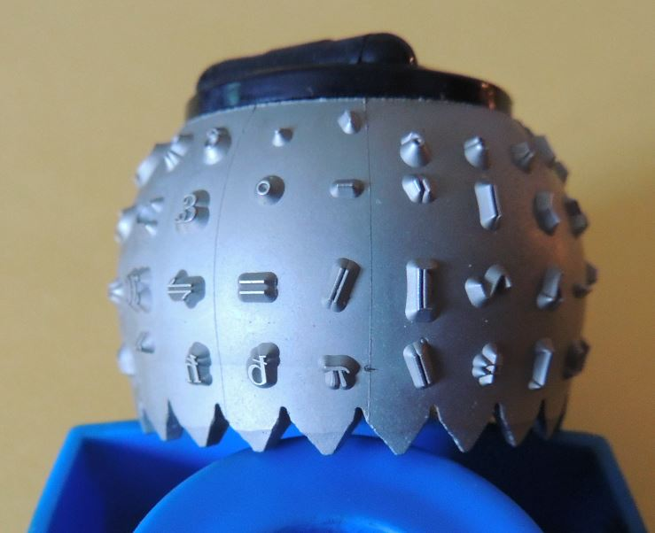 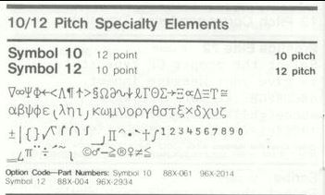

### Trifolds

Another new trifold has been added to the collection, the first of a series covering IBM innovation that helped to change the world. It will appear on the museum web site trifold page when the author returns from the Antipodes.

### Other

Last time I reported on the offer of a working System/3. The owner subsequently informed us that he’s not yet ready to part with it, and we may have to wait for illness or demise. At least that gives us time to try and find £5K for shipping charges. We live in hope!